# Christmas Cheer Laser, part 5

## Where-Object vs. Select-Object

For me, this was one of the most confusing parts of PowerShell, and in my humble opinion (IMHO) it is due to poor naming. The Where_Object cmdlet tests objects as they travel down the pipeline and drops any object that doesn’t pass the test. Ok, then what does Select-Object do? Select-Object also examines the objects going down the pipeline; usually it allows all objects to pass, but it only allows certain properties of each object to pass. I think Select-Property would be a much better name. For example, Get-ChildItem has a lot of properties; if we were only interested in outputting path for each object, we would say this.  
Get-ChildItem | Select-Object -Property Path, or, dir | select path

## Answer to the Previous Question

1. Do a search of /home/elf to a “shallow” depth. Compute the MD5 hash of all the files you find and output the name and path of the file that has a hash of 25520151A320B5B0D21561F92C8F6224  
   First, the hint tells us to search /home/elf to a “shallow” depth. I will guess “shallow” means 2 layers deep.  
   Get-ChildItem /home/elf -Depth 2  
   This will generate a lot of output, so I won’t show it. Now compute the MD5 hash of each file. The cmdlet is Get-FileHash and we need to use -Algorithm MD5  
   Get-ChildItem /home/elf -Depth 2 | Get-FileHash -Algorithm MD5  
   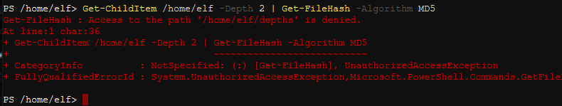  
   Oops. Access to the path '/home/elf/depths' is denied. You can’t take the hash of a directory; we only want files. If you search on “get-childitem files only” you will find there are a lot of ways to do this; the -File switch is one of them.  
     
   There’s still a lot of output. We need to narrow that down to one file. Let’s filter on the hash, but, what do we filter on? Let’s put the output of our last statement into Get-Member and see what it holds.  
     
   Get-ChildItem /home/elf -Depth 2 -File | Get-FileHash -Algorithm MD5 | Get-Member  
   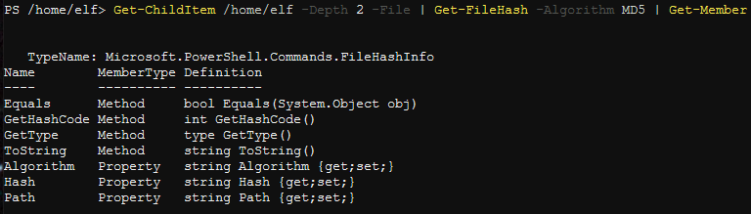  
   So, the output is an object with properties Algorithm, Hash, and Path. Note that Hash is a string.  
     
   Get-ChildItem /home/elf -Depth 2 -File | Get-FileHash -Algorithm MD5 |  
   Where-Object {$_.Hash -eq '25520151A320B5B0D21561F92C8F6224'} | fl  
   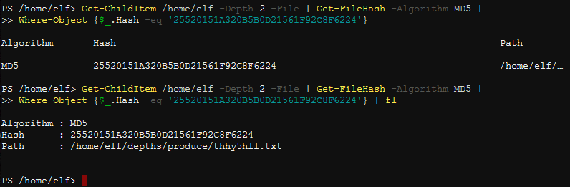  
   Rather than typing that long path, or copying and pasting, we can just pipe our answer into Get-Content.  
   Get-ChildItem /home/elf -Depth 2 -File | Get-FileHash -Algorithm MD5 | Where-Object {$_.Hash -eq '25520151A320B5B0D21561F92C8F6224'} | gc  
   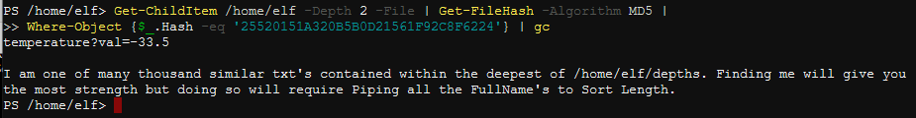

Great! At the top of the riddle, it says temperature?val=-33.5. Two parameters down, two to go.  
  
This search will be like the last two you’ve done. This time you want to recursively search the entire /home/elf/depths tree. Then sort the entries by the length of the FullName parameter and take the file with the longest FullName.

## Question

1. What is the riddle at the end of this clue?